NAME: FATIMA BUKAR WAZIRI
CLASS: JSS 3E
NO: 33
ASSIGNMENT: STAR TOPOLOGY
SCHOOL: RUBY SPRINGFIRLD COLLEGE
TEACHER’S NAME: MR ADAMS

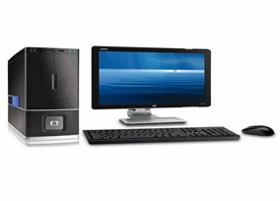

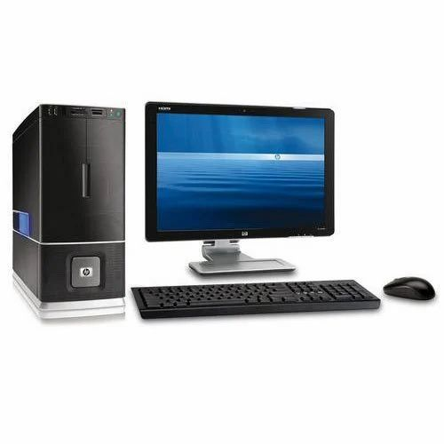
PC2


PC1 HUB PC3

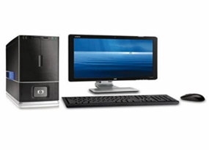

PC5 PC4

